How To Open a Feed

CSV feed
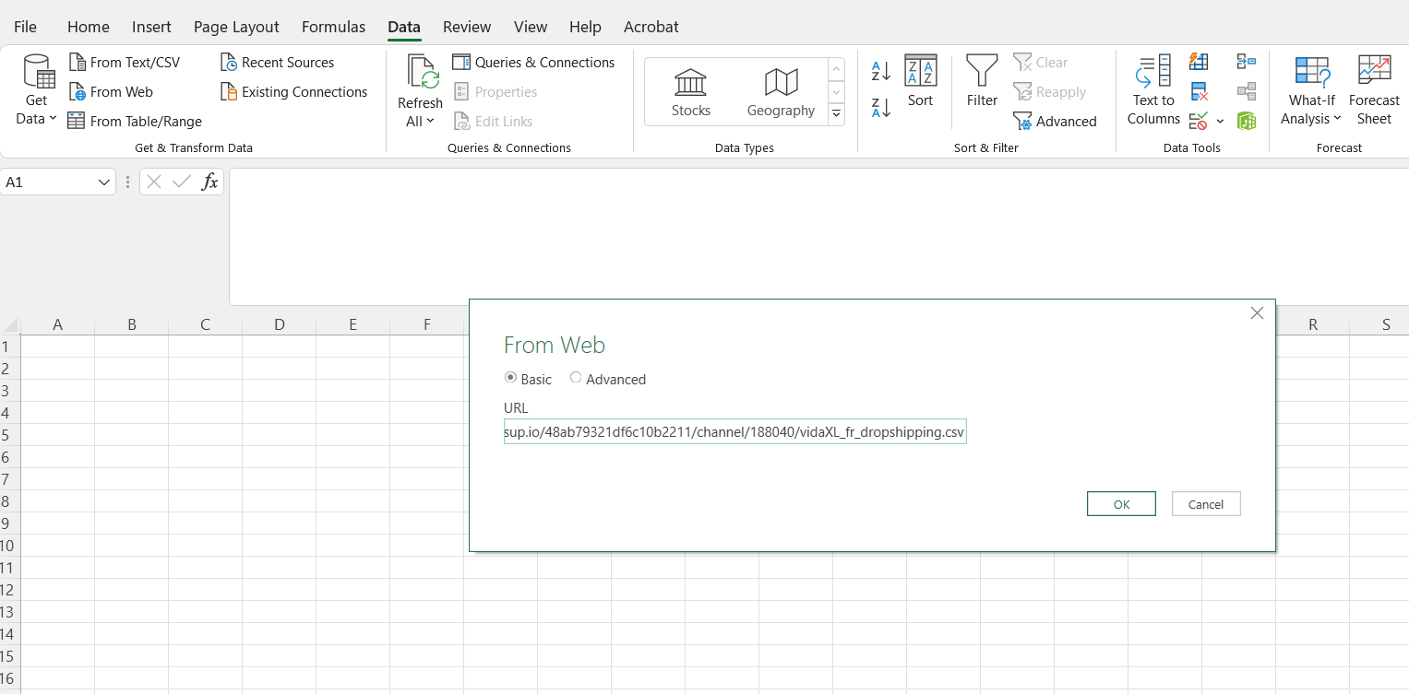
- Open a blank Excel file and click on the “From Web” option located on the top left corner of your screen.
④
③
②
①
- Once you have performed the needed action, a window will appear before you. Paste the file link that was sent to you in the field “File name” then click on “Open”.

- You almost there! Once you have clicked on the “Open” option, a series of windows will appear before you. To Successfully view the feed, kindly follow the images below:

- After opening the preview interface, click ‘Transform Data’

Select all tables -> Select Data Type as 'Text' -> Select ‘Replace current’ -> Confirm that the data is displayed correctly -> Click ‘Close and Load’ -> Open the feed successfully
